September
2023
CP English III
Sunday | Monday | Tuesday | Wednesday | Thursday | Friday | Saturday
 |  |  |  |  | 1 | 2
 |  |  |  |  | Tyrese’s bday
3 | 4 | 5 | 6 | 7 | 8 | 9
Malachi’s bday | LABOR DAY | First day of school!  Class procedures  Hailey G’s bday | Introductions  Poetry activity | Pre-assessment for first unit | Signed paperwork due  Begin Native American myths
10 | 11 | 12 | 13 | 14 | 15 | 16
 | Do Nows begin  September 11 poems and reflection | Linkit Assessment  Alfredo’s bday | Native American Myths  Yeritza’s bday | Researching a tribe  Picture day | Work on mini-project
17 | 18 | 19 | 20 | 21 | 22 | 23
 | Work on mini-project | Native American quiz  Ethan O’s bday | Read “Balboa”  Paul B’s bday  Avalynne’s bday | Mini-project due  Work with “Balboa” | Open-ended question for Balboa  Jiani’s bday  Hayden’s bday
24 | 25 | 26 | 27 | 28 | 29 | 30
 | Read “A Desperate Trek” | Southwest Journal research | Poems | Southwest Journal Due  Poems  Gabriel S’s bday | Short read choice  First test Tuesday | 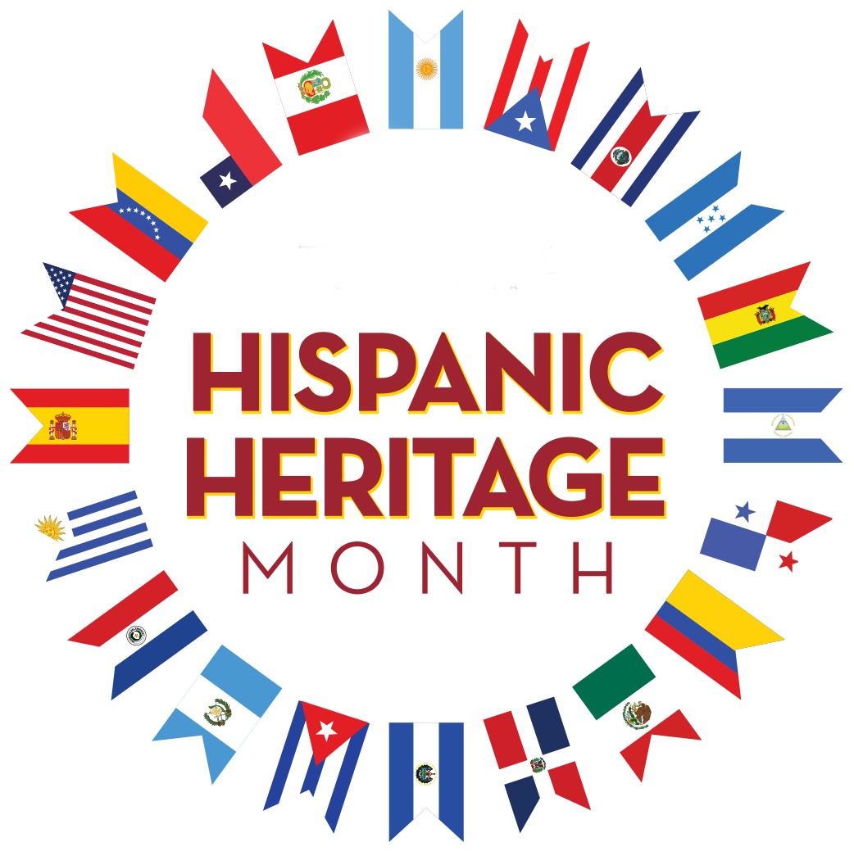
Hispanic Heritage Month
Sept. 15 – Oct. 15

